Annual Report to Parents
2022– 2023

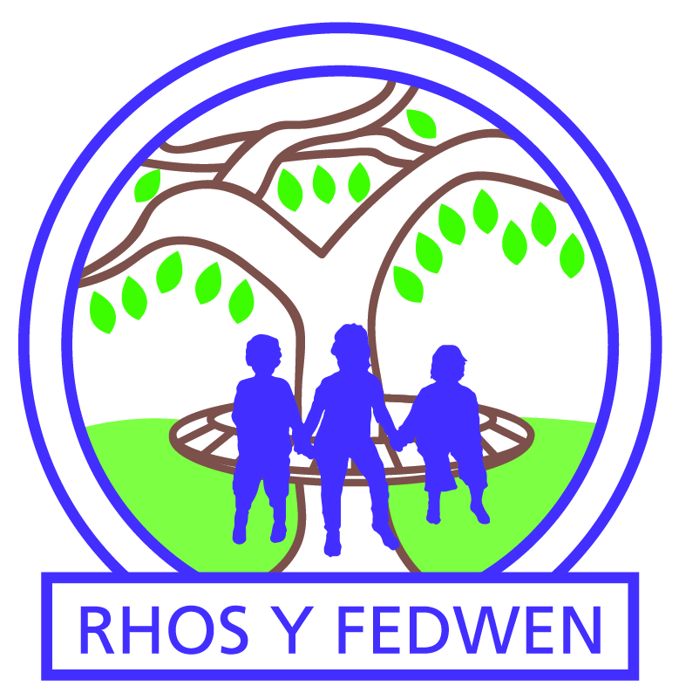

Rhos y Fedwen Primary School

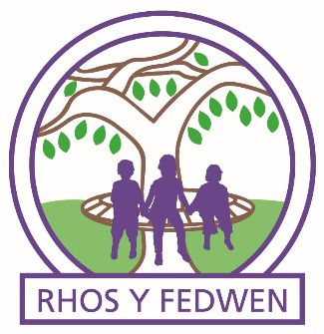
Annual Report to Parents 2022-2023

Welcome from the chair of Governors
I am pleased to present the Annual Report to Parents for the 2022-2023 academic year. The Annual Report to Parents is a document that Governors provide to parents outlining events and developments at the school over the last 12 months. This has been another eventful and challenging time as the effects of the Covid-19 pandemic are still being felt, and will be with us for many years as your children try and recover the time lost during the worst of the pandemic. The Governors, Sarah Helm and staff of the school have followed Welsh Government, Public Health Wales and Local Authority advice and guidance to ensure that all required actions have been continued in order to maintain safety and be alert to the risk of various infections. Following Welsh Government guidelines, the Governing Body continued to carry out governance duties mostly using a mix of face-to-face meetings and virtual meetings, to support and monitor the ongoing actions and the management of the school.
The wellbeing of pupils and staff has continued to be at the forefront of all of our meetings. I would like to thank the Local Authority staff for their help, support and guidance during the planned and current works to improve the buildings and external areas, this major investment in our school will ensure our children have the best facilities possible. With your support as parents and carers, alongside the work of the staff and Governors, we will ensure our students, from 3 to 11 years old, the best opportunities possible.
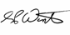

A Note from the Headteacher
I am delighted to be able to bring you this annual report. Rhos Y Fedwen is proud to be growing as a community focused school and it is great to be able to celebrate another successful year with you.
We are lucky to have such fabulous learners and our dedicated staff team working hard to fulfil our vision
‘Working Together We Can All Succeed’
Our school gets better every day as we aim to always be Ready, Respectful and Safe. We are proud to be Rhos Y Fedwen #proudtobeRyF. We want to be a rainbow in someone else’s cloud #bearainbow and we strive to be the best we can be #bethebestyou. It is my privilege to be able to lead and serve at Rhos Y Fedwen Primary School.
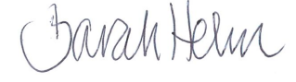

Governor’s Responsibilities

  - Ensuring clarity of vision, ethos and strategic direction
  - Holding headteachers to account for the educational performance of the school and its pupils, and the effective and efficient performance management of staff
  - Overseeing financial performance of the school and making sure its money is well spent
The role of a governor is largely a thinking and questioning role, not a doing role. Governors must maintain a strategic view, and not get involved in the day-to-day management and operational responsibilities within the school. The headteacher is responsible for the internal organisation, management and control of the school, and the implementation of the strategic framework established by the governing body.
The simple answer to this is that it supports the work of the school. It provides a different perspective from that of the staff and can help the school to plan for the future and to monitor that it is doing what it says it is doing. It also helps to evaluate the effectiveness of the school’s activities. In short, it acts as a critical friend.
What the governing body does not do is to get involved with the day-to-day running of the school. You must be clear that this is the responsibility of the Headteacher. Although members of the governing body may have skills that they can use to support the school, e.g. in finance or health and safety, it is important to remember not to tell the staff how to do their jobs. Although we probably all have an idea of what makes a good teacher, governors do not get involved in making judgements about teachers. The governing body’s role is to ensure that there are arrangements in place for a headteacher and senior staff to monitor how staff are performing.

National Test Data
At then end of the academic year we collected data through national tests and ongoing school processes.

Attendance
Our attendance target for 2022-23 was 93.8%. The actual attendance was 90.1%. Authorised absence was 7.2%. Unauthorised absence was 2.7%.

Organisation
Our school has single and mixed age group classes across the school split into Early Years (Nursery) Lower School (Reception to Year 3) and Upper School (Year 4 to Year 6).
Class structure for the academic year 2022 – 2023
Class | Year Group | Teacher
Dosbarth Oren | Nursery | Mrs Martin
Dosbarth Melyn | Reception / Year 1 | Mrs Farr
Dosbarth Gwyrdd | Year 2/3 | Miss Jones/Miss Giles
Dosbarth Glas | Year 4 / Year 5 | Miss Amor/Miss Whitehouse
Dosbarth Porffor | Year 5 /Year 6 | Mrs Phillips

School Administration
Mrs Alex Vedmore
Caretaker
Mr Will Tauati

Our Governing Body
Name | Type of Governor | Start Date | End Date
Steve Winter – Chair  Rhos y Fedwen Primary School  01495 356021 | Community | 20/11/2019 | 20/11/2023
Past Jason Pennington | Community | 31/12/2017 | 31/12/2024
Cllr David Wilkshire | LA appointed | 09/10/2017 | 09/10/2024
Mel Madden | Parent Representative | 20/11/2019 | 20/11/2023
Joanne Tauati-Edmunds – Vice Chair | Parent Representative | 20/11/2019 | 20/11/2023
Jackie Stephens | Parent Representative | 05/05/2021 | 05/05/2025
Jack Thomas | Staff Representative | 26/09/2022 | 26/09/2025
Rachael Farr | Teacher Representative | 26/09/2018 | 26/09/2025
Gareth Davies | LA appointed | 24/01/2023 | 24/01/2026
Jon Mower  governor.support@sewaleseas.org.uk | Clerk | 27/09/2018 | n/a
Our Rhos y Fedwen School Development Plan Priorities 2022-2023

- Strengthen leadership and governance to ensure school development.

- Develop our curriculum including pedagogy and enquiry approach.

- Develop our approach to assessment and progression to ensure learner progression.

- Ensuring well-being through diversity, equity and inclusion.

Policies in place
Please find below a list of statutory policies that all schools in Wales need to have in place
Blaenau Gwent Policies | School Policies
- Admissions Guidance  - Adoption/Surrogacy Leave  - Alcohol and Substance Misuse Policy  - ALN Strategy  - Attendance Management Policy  - Awarding Grants  - Capability Procedure for school-based staff  - Carers Policy  - Community Tuition Access Health Need  - Critical Illness & Working Guidelines  - Cross Matching Process for Schools  - Dignity at Work Policy  - Disciplinary Procedure for school-based staff  - Domestic Abuse, Violence & Sexual Violence Policy  - Educational Visits  - Education of Children with a Parent or Close Relative in Prison  - Education of Children Looked After  - EOTAS  - Exclusion Guidance  - Grievance policy for school-based staff  - Hard to Place Protocol  - Inclusion Strategy  - IVF Guidelines  - Managed Move Protocol  - Maternity Leave  - Menopause and the Workplace: A Guide for Managers  - Partnership Agreement Final Post Consultation  - Pastoral Support Guidance  - Pay Policy  - Performance Management for Teachers  - Physical Intervention  - Positive Relationships & Behaviour Strategy  - Pregnant School Girls Guidance  - Reduced Timetable  - Redundancy Policy  - Relationships (Anti-Bullying)  - Schedule of Leave of Absence  - School Admissions  - Severe Weather Procedure  - Terms of Reference VLP  - Traveller Attendance Guidance  - Volunteers in the Workplace  - Well-being in Education Strategy  - Whistleblowing Policy | - Accessibility  - Additional Learning Needs  - Administering Medicines  - Anti-Bullying  - Anti-discriminatory Strategy  - Assessment  - Attendance  - Blended Learning  - Charging & Remissions  - Children Who are Looked After  - Collective Worship  - Complaints  - Education of Children with a Parent or Close Relative in Prison  - E-Safety  - Equity, Diversity & Inclusion  - Feedback  - GDPR  - Gifts & Hospitality  - Healthy & Safety  - Lettings  - Marking  - Mobile Phone  - Positive Behaviour Management & Relationships  - Privacy Notice  - Pupils Acceptable Use of ICT  - Pupil Medical Needs  - Relationships and Sex Education  - Safeguarding  - School Uniform & Appearance  - Secure and Shelter Procedure  - Social Media  - Volunteers

Budget 2022 - 2023
Delegated Budget | 777,764
Balance Brought Forward | 183,031
Total Delegated Budget | 960,796
Grants
Education Improvement Grant | 49,721
Pupil Deprivation Grant | 69,050
Early Years Pupil Deprivation Grant | 14,950
Professional Learning for Teachers | 3,509
Curriculum for Wales Professional Lead Grant | 5,000
Health well-being and Equity lead | 5,000
School to school model 2 | 4,000
LA Grant- Recruit, recover, raise standards additional April 22 – August 22 | 4,062
LA Grant- Recruit, recover, raise standards additional September 22 – March 23 | 5,687
LA Grant- ALN April 22 – March 23 | 2,435
NPQH participant | 500
Income | 163,914
Expenditure
Employees | 559,775
Other Employee Costs | 70,500
Energy | 17,539
Capitation | 27,000
Premises | 47,367
Communication | 2,433
Transport | 600
Central Services | 92,703
Total Expenditure | 817,917

2022 – 2023 School Calendar
Date | Start | Half Term Starts | Half Term Ends | Term Ends
Autumn | 2.9.22 | 31.10.22 | 4.10.22 | 23.12.22
Spring | 9.1.23 | 20.2.23 | 24.2.23 | 31.3.23
Summer | 17.4.23 | 29.5.23 | 2.6.23 | 21.7.23

Teaching and Learning and Curriculum Planning
All staff have continued planning for the implementation of Curriculum for Wales. Curriculum for Wales is driven by four purposes. These are that all our children and young people will be supported to develop as:
- Ambitious, capable learners who are ready to learn throughout their lives
- Enterprising, creative contributors who are ready to play a full part in life and work
- Ethical, informed citizens who are ready to be citizens of Wales and the world Healthy,
- Confident individuals who are ready to lead fulfilling lives as valued members of society.

There are 6 Areas of Learning Experience (AoLE)
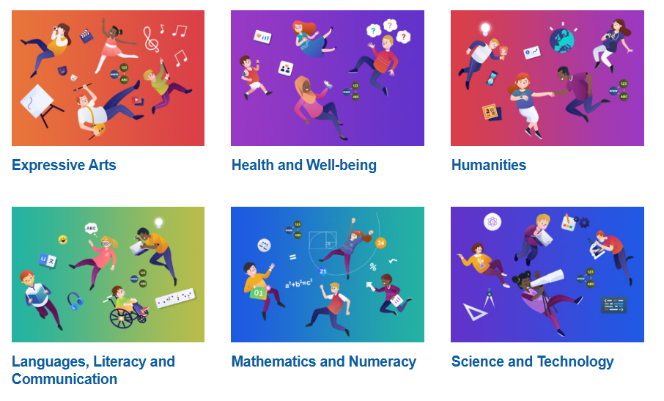
The Expressive Arts Area of Learning and Experience (Area) spans five disciplines: art, dance, drama, film and digital media and music. Although each discipline has its own discrete body of knowledge and body of skills, it is recognised that together they share the creative process.
The Health and Well-being Area of Learning and Experience (Area) provides a holistic structure for understanding health and well-being. It is concerned with developing the capacity of learners to navigate life's opportunities and challenges. The fundamental components of this Area are physical health and development, mental health, and emotional and social well-being. It will support learners to understand and appreciate how the different components of health and well-being are interconnected, and it recognises that good health and well-being are important to enable successful learning.
The Humanities Area of Learning and Experience (Area) seeks to awaken a sense of wonder, fire the imagination and inspire learners to grow in knowledge, understanding and wisdom. This Area encourages learners to engage with the most important issues facing humanity, including sustainability and social change, and help to develop the skills necessary to interpret and articulate the past and the present.
The Area encompasses geography; history; religion, values and ethics; business studies and social studies. These disciplines share many common themes, concepts and transferable skills, while having their own discrete body of knowledge and skills. Learners may also be introduced to other complementary disciplines, such as classics, economics, law, philosophy, politics, psychology and sociology, if and where appropriate.

The development of mathematics has always gone hand in hand with the development of civilisation itself. A truly international discipline, it surrounds us and underpins so many aspects of our daily lives, such as architecture, art, music, money and engineering. And while it is creative and beautiful, both in its own right and in its applications, it is also essential for progress in other areas of learning and experience.
What is more, numeracy – the application of mathematics to solve problems in real-world contexts – plays a critical part in our everyday lives, and in the economic health of the nation. It is imperative, therefore, that mathematics and numeracy experiences are as engaging, exciting and accessible as possible for learners, and that these experiences are geared towards ensuring that learners develop mathematical resilience.
The importance of science and technology in our modern world cannot be overstated. Developments in these areas have always been drivers of change in society, underpinning innovation and impacting on everyone’s lives economically, culturally and environmentally. As such, the Science and Technology Area of Learning and Experience (Area) will be increasingly relevant in the opportunities young people encounter and the life choices that they make.
Ready access to vast amounts of data requires all learners to be able to assess inputs critically, understand the basis of information presented as fact, and make informed judgements that impact their own behaviours and values. They need to develop the ability to meaningfully ask the question, ‘Just because we can, does that mean we should?’
Teaching Time
 | Lower School |  | Upper School
 | Times | Allotted Time | Times | Allotted Time
Registration | 8:55am – 9:00am | 5 mins | 8:55 – 9:00am | 5 mins
Session 1 | 9:00am – 10:25am | 1 hour 25 mins | 9:00am – 10:35am | 1 hour 35 mins
Break | 10:25am -10:45am | 20 mins | 10:35am –10:55am | 20 mins
Session 2 | 10:45 -12:00 | 1 hour 15 mins | 10:55am –12:20pm | 1 hour 25 mins
Lunch | 12:00 – 1:00 | 1 hour | 12:20pm – 1:00pm | 40 mins
Session 1 | 1:15 – 2:00 | 45 mins | 1:15pm – 3:00pm | 1 hour 45 mins
Break | 2:00 – 2:10 | 10 mins | - | -
Session 2 | 2:10 – 3:00 | 50 mins | - | -
Total teaching time per day |  | 4 hours 15 mins |  | 4 hours 45 mins
Total Assembly per week |  | 1 hour 15 mins |  | 1 hour 15 mins
Total teaching time per week |  | 21 hours 15 mins |  | 23 hours 45 mins

Visits, Trips and Visitors to School

September
- Kerbcraft – Y2
- Drama Workshop – Y4, Y5, Y6
- Mabinogi at Raglan Castle – Y4, Y5, Y6
- Residential trip to Jamie’s Farm – Y6

October
- Dogs Trust Workshop – Y2 – Y6
- Ffin Dance – Y4 – Y6
- Children’s Grand Council Meeting – Head pupils
- Y6 Transition Day to Ebbw Fawr

November
- Specturm Workshop – Reception – Y6
- Louby Lou’s Welsh Folk Tales Session – whole school
- Taekwondo Lessons – Y5
- Winter Dance Faktry Festival – Y4 – Y6

December
- Design to Smile Sessions – Nursery – Y2
- Christmas Movie Night – PTA
- Christmas lunch at Jamie’s Farm – Y6
- Dizzy Kids Play Centre – Nursery
- Pantomime at Beaufort Theatre – Reception – Y6

January
- Kaiko Drumming – Y6
- Brilliant Bird Workshop with Blaenau Gwent Biodiversity Officer – Nursery, Y6
- Cluster Choir Sessions – Y6
- Library Visit – Reception, Y1

February
  - Netball Club – Y3 – Y6
  - Owl Sanctuary Visit – Reception, Y1
  - Library Visit – Y4, Y5, Nursery

March
  - Safer Internet Training - Heddlu Bach
  - Kerbcraft – Y1
  - Library Visit – Y6, Y5, Y3, Y2
  - Children’s Grand Council Meeting – Head pupils
  - Easter Disco – PTA
  - Anti-social Behaviour Assembly – Police Liaison Officer – Y3 – Y6

April
  - Police and Commissioner Course – Heddlu Bach
  - Water Awareness Session – Y3 – Y6
  - Traffic Control Course – Heddlu Bach
  - First Aid Course – Heddlu Bach

May
  - Reservoir Safety – Y3 – Y6

June
  - Children’s Grand Council Meeting – Head pupils
  - Intergenerational Project – Eco Warriors
  - Playmakers Award – Y6

July
  - Intergenerational Project – Eco Warriors
  - Residential Trip to Gilwern Outdoor Centre – Y6
  - End of year trips to Parc Bryn Bach – whole school
  - Governor Meeting with Eco Committee

Gwent Music Service visited throughout the year working across the school, teaching whole class instrument lessons.

Community Links

- Fit & Fed scheme

- Families First fortnightly session

- Uniform Bank

- Satellite Food Bank

- Hospice of the Valleys

- PC Powell, Schools liaison officer

- Flying Start

- Llys Nant Y Mynydd -Extra care housing scheme

Other Matters

- Rhos y Fedwen Primary School is an English medium school and Welsh and French taught in every year group as a second language.

- Our school teaches our Curriculum for Wales in pursuit of the 4 purposes. Our children are supported to develop as ambitious, capable learners; enterprising, creative contributors; ethical, informed citizens and healthy, confident individuals.

- Every child receives music tuition provided by Gwent Music.

- Our school prospectus is updated regularly and is available on request at the school office.

- We use Parentmail and Twitter as our main forms of communication to reduce the use of paper.

- The school has five sets of toilets for pupils, which are cleaned daily.

- We promote healthy eating by
  - encouraging healthy lunch boxes
  - promoting water on desks

- We have links with other schools in our cluster, other local schools, schools outside of the local authority and Ebbw Fawr Learning Community Secondary Phase.

- Through the 21st Century Schools initiative, improvement works have been planned to begin at the end of the academic year 22-23 and 23-24.

